To download VirtualBox, go to the official site [**virtualbox.org**](https://www.virtualbox.org/wiki/Downloads) and download the latest version for windows.

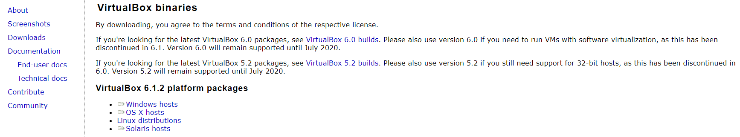

**Beginning with the Installation:**

* **Getting Started:**

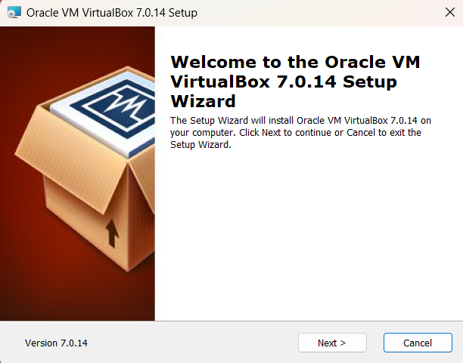

* **Select Installation Location:**

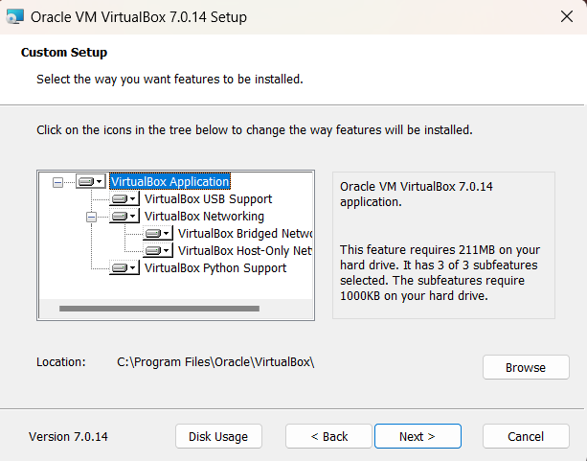

* **Creating Entries and Shortcuts:**

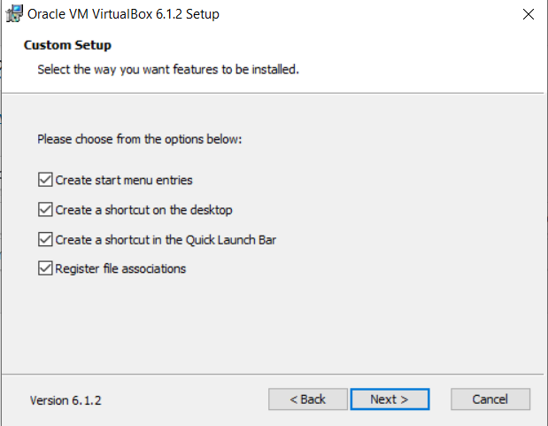

* **Ready to Install:**

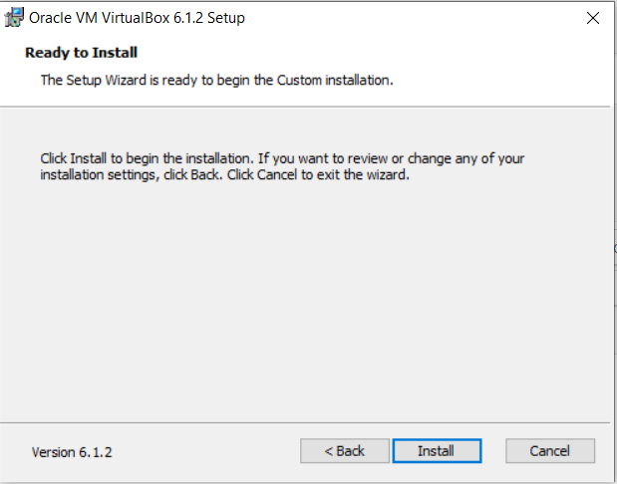

* **Installing Files and packages:**

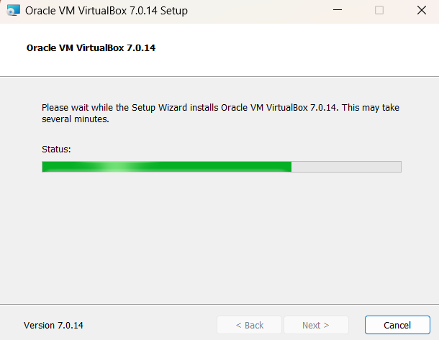

* **Finished Installation:**

When you will open VirtualBox it will look like as shown below:

* **Installing kali Linux on virtual box:**

Upon starting up VirtualBox, select “New” (Machine -> New).

Before stating the (“New”) go to [www.kali.org](http://www.kali.org) and download kali Linux file.

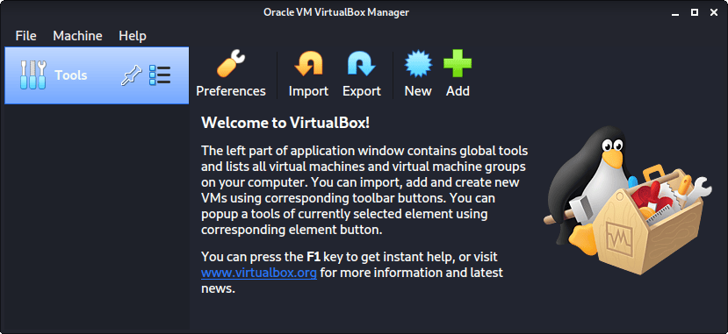

* **Name and operating system:**

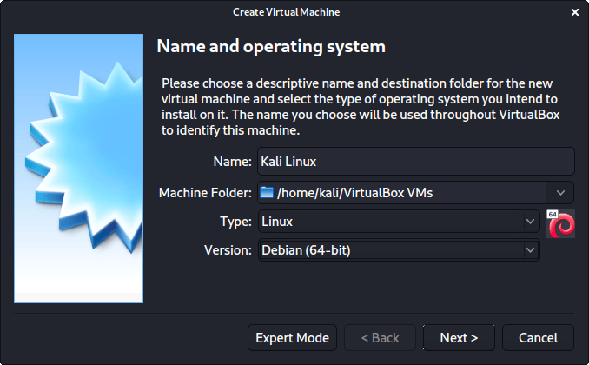

* **Memory size:**

When we make the general VMs, we select 2048 MB (2GB) for RAM, but we often increase this for our personal machines as we have high-performing devices with spare RAM which Kali can utilize.

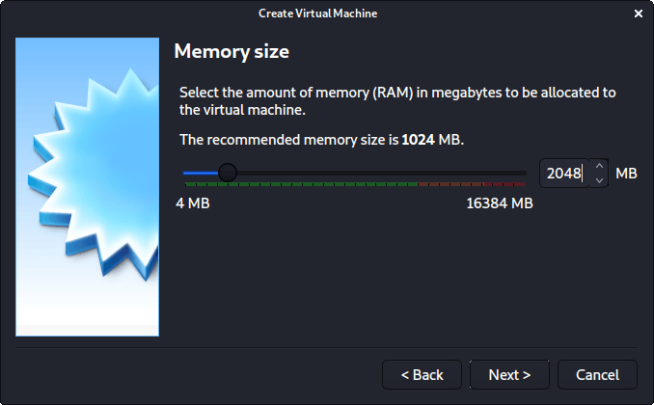

* **Hard Disk:**

The screen below, “Hard disk”, allows us to Create a new virtual disk now.

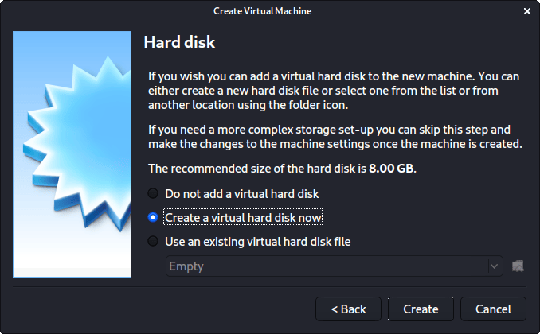

* **Hard disk file type:**

For the “Hard disk file type”, we select VDI (VirtualBox Disk Image) (and its the default option).

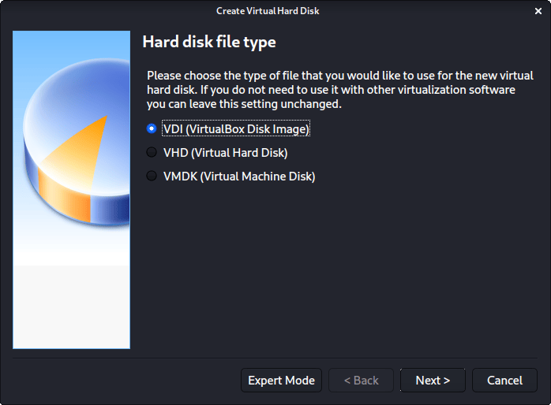

* **Storage on physical hard disk:**

For the following screen, “Storage on physical hard disk”, we go with the default option of Dynamically allocated.

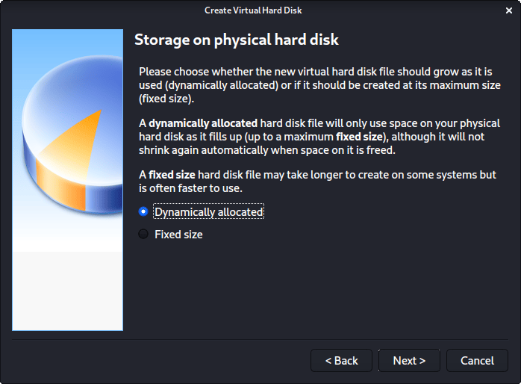

* **File location and size:**

Now with “File location and size”, we can now define how large the virtual hard disk will be. We use 80.00 GB for our VMs.

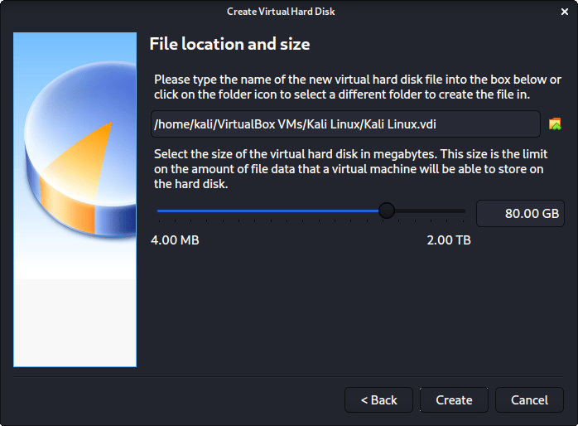

**The final settings view looks like the following:**

